Basic Fluid Simulation

By Niels Daemen

In this short document I will describe the (as far as I know) simplest possible fluid simulation method. This method will not produce scientifically accurate results and was never intended to do so.

# The model

The fluid model consists of a 2 dimensional grid of cells.

Each cell has the following properties:

|  |  |  |
| --- | --- | --- |
| **Property** | **Abbreviation** | **Defined where in the cell** |
| Horizontal velocity | Vx | Middle of right edge |
| Vertical velocity | Vy | Middle of top edge |
| Pressure | P | Center |

These properties are not all defined at the center of the cell, the velocities are defined exactly on the border between cells. They are therefore exactly in between the centers of the cells, which is where the pressures are defined.

Figure 1 - Fluid model

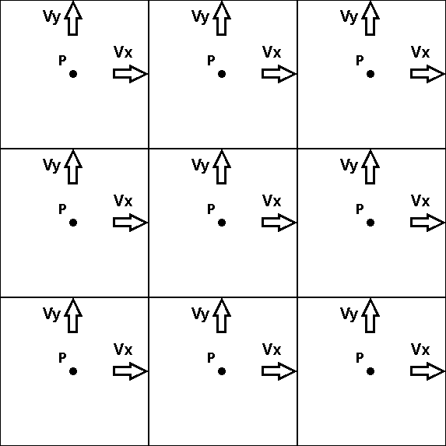

# Iteration

One iteration or timestep consists of the following steps:

1. Calculating pressure
2. Calculating velocities
3. Advection

Every step needs to be completed for each cell in the grid, before the next step is executed

# Calculating pressure

Pressure can be imagined as being the amount of fluid that is in a cell.

The velocities can be imagined as a flow of fluid from a cell to a neighbouring cell. Therefore the change in pressure is equal to the net inflow to the cell. To calculate the net inflow to the cell, the outflow is simply subtracted from the inflow. This is done for both x and y directions.

* The horizontal inflow to a cell IS the outflow of the cell to the left
* The vertical inflow to a cell IS the outflow of the cell below

**·**Positively proportional **·** Negatively proportional

$$P +=Vx(in)-Vx\left(out\right)+ (Vy(in)-Vy\left(out\right)$$

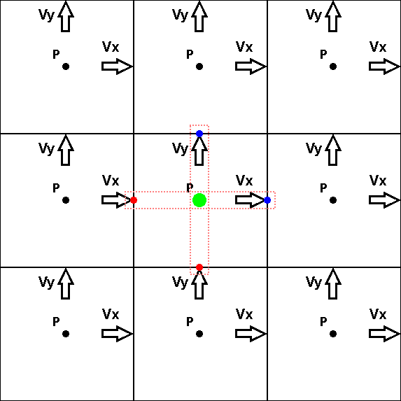

Figure 2 - Calculating pressure

# Calculating velocities

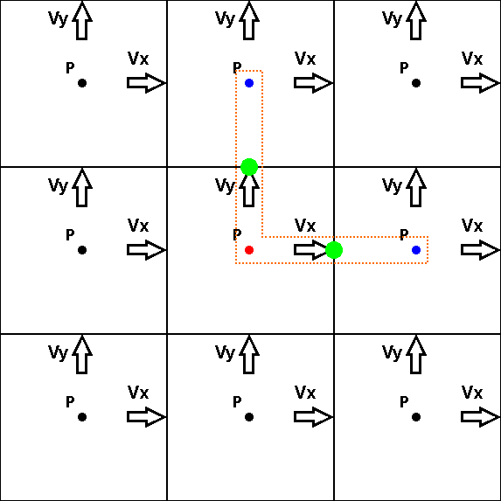The change in the velocity trough a point is proportional to the pressure across it.

Figure 3 - Calculating Velocities

$Vx +=P(this)-P\left(right\right)$ $Vy +=P(this)-P\left(above\right)$